LAB PRACTICE ASSIGNMENT: 1

- Create a table EMPLOYEE with following schema:

(Emp_no, E_name, E_address, E_ph_no, Dept_no, Dept_name,Job_id , Salary)
- Add a new column; HIREDATE to the existing relation.
- Change the datatype of JOB_ID from char to varchar2.
- Change the name of column/field Emp_no to E_no.
- Modify the column width of the job field of emp table

Step 1: Create Database

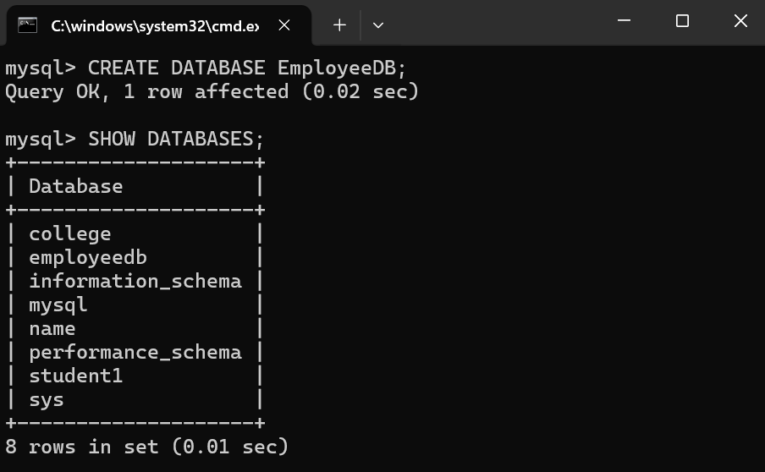

Step 2: Use Database
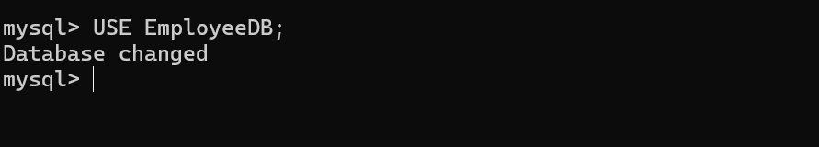
Step 3: Create EMPLOYEE Table

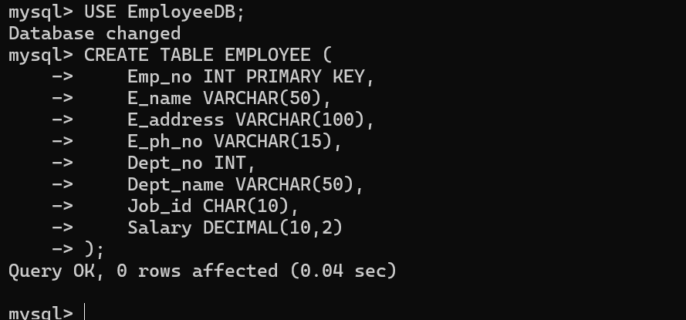

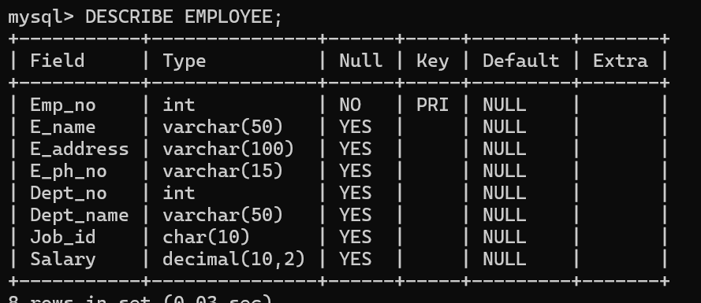

Step 4: ALTER TABLE (Add Column)

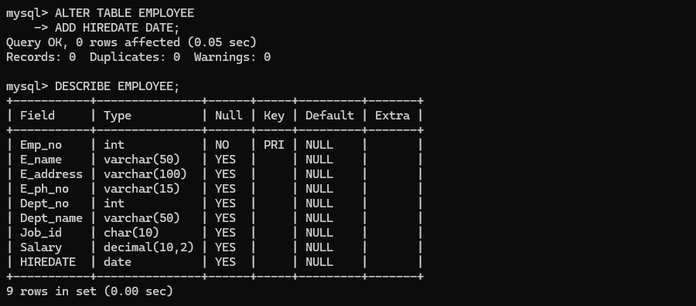

Step 5: ALTER TABLE (Modify Data Type)

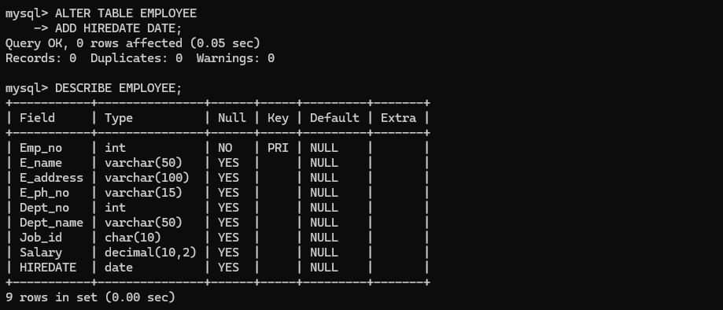

Step 6: ALTER TABLE (Rename Column)

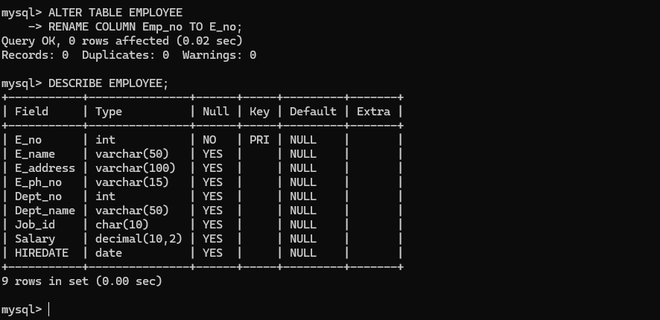

Step 7: ALTER TABLE (Modify Column Width)

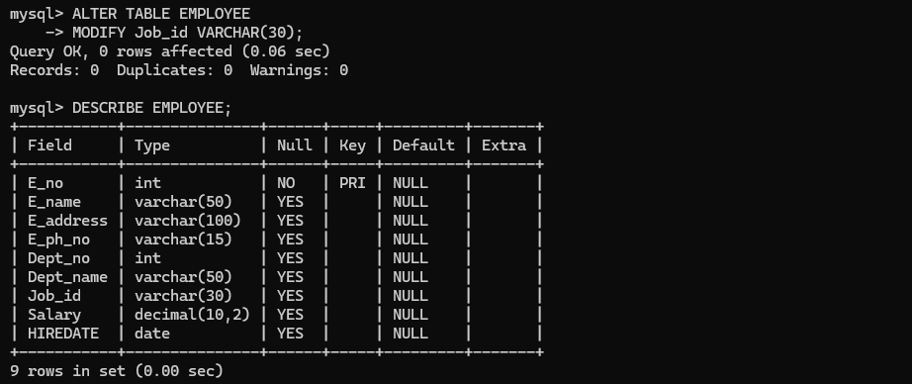

Step 8: DROP TABLE

